Name: Sachin Vishwakarma Roll No:537

Name: Sachin Vishwakarma

Roll No.: 537

Class : M.Sc. CS - 1

Subject: Business Intelligence and Big Data Mini Project: Mongo DB and it’s commands.

Name: Sachin Vishwakarma Roll No:537

Following are some of the commands of MongoDb and it’s Output : 1.To Run the Mongo

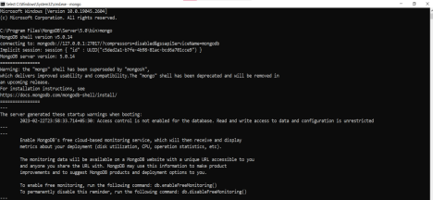

>Show db Command

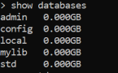

>use db



>db



Name: Sachin Vishwakarma Roll No:537

>show collections



> Delete Database



> Create collections and insert one row

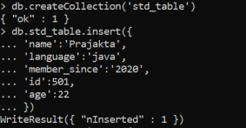

>Insert Multiple Rows

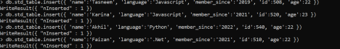

> Search in a MongoDb Database



> Limit the number of rows in output



Name: Sachin Vishwakarma Roll No:537

Count the number of rows in the output



>Find the first row matching the object

